**EXP NO:3B ROLL NO: 231901048**

**DATE: 7.08.24 NAME:SHAMRUDHA VARSHINI.P**

**3.B CRIMPING OF CABLES WITH RJ45 CONNECTOR.**

**AIM:** Study of RJ45 and CAT cabling and connection using crimping tool.

**RESOURCES REQUIRED:**

* **H/W Requirements:** RJ45, CAT cables, Crimping Tool, Printer, and Internet Connec- tion.
* **S/W Requirements:** Cisco Packet Tracer.

**THEORY:**

**RJ45:**

RJ45 cable is used for connecting the ALL HMI and engineer station through a switch to com- municate with each other. It is used to download any modifications and which is made in graphics in the engineering station. RJ45 cable is also used to communicate the printer with the computer. There are four pairs of wires in an Ethernet cable, and an Ethernet connector (8P8C) has eight pin slots. Each pin is identified by a number, starting from left to right, with the clip facing away from you.

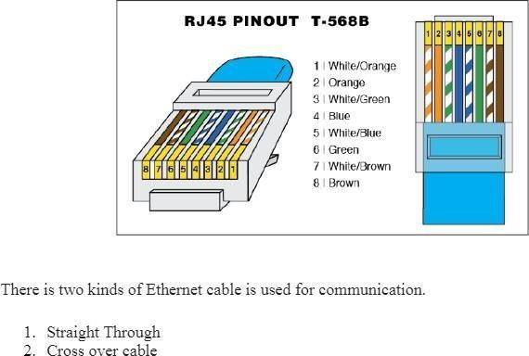

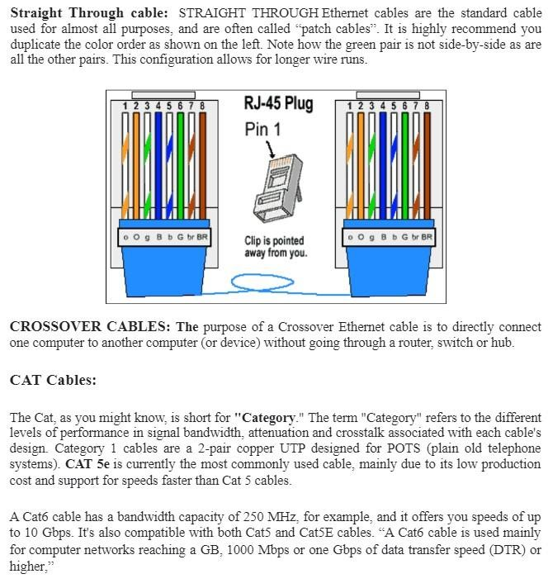

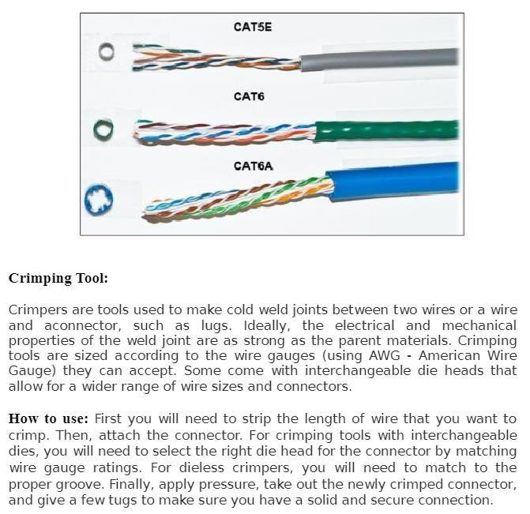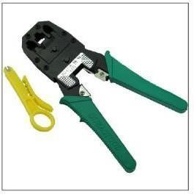

**RESULT:**

Thus the RJ45 and CAT cabling and connection using crimping tool is studied.